**Design Thinking:**

**Designing a traffic intersection:**

The design has three levels; ground level,fly-over,under-pass. Keeping in mind high traffic in the city area, the design is best suited.

Ground Level:

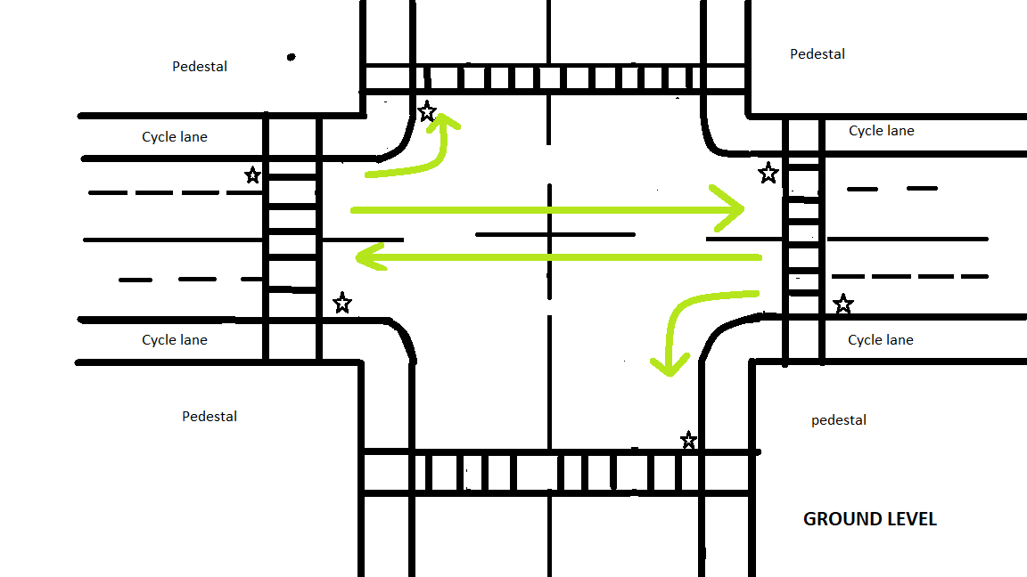

**\*the Star in the above illustration are the traffic lights. And the zebra-crossing are located near to the traffic lights.**

The ground level has traffic flow from are as showing in the illustration. We have the need of traffic light to halt the traffic only when people have to cross road. For the people who are cycling, they can use the zebra-crossing to cross the road. We have only two side flowing traffic so that there are very low chances of having traffic jams.

**Flyover bridge:**

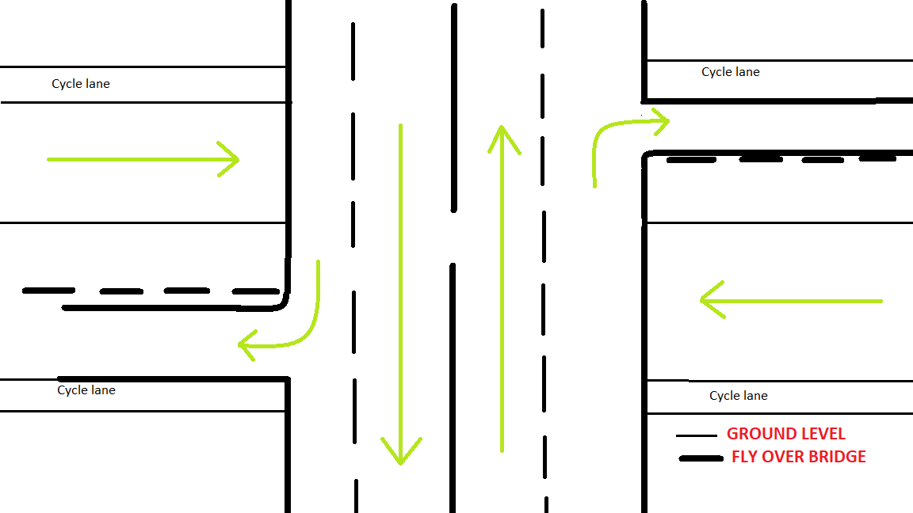

The end of flyover in the right side and left side are as shown below. The climbing and decent from the flyover should not be very far from the intersection. There should be sign boards to alert the drivers when there is a turn ahead.

**Underpass:**

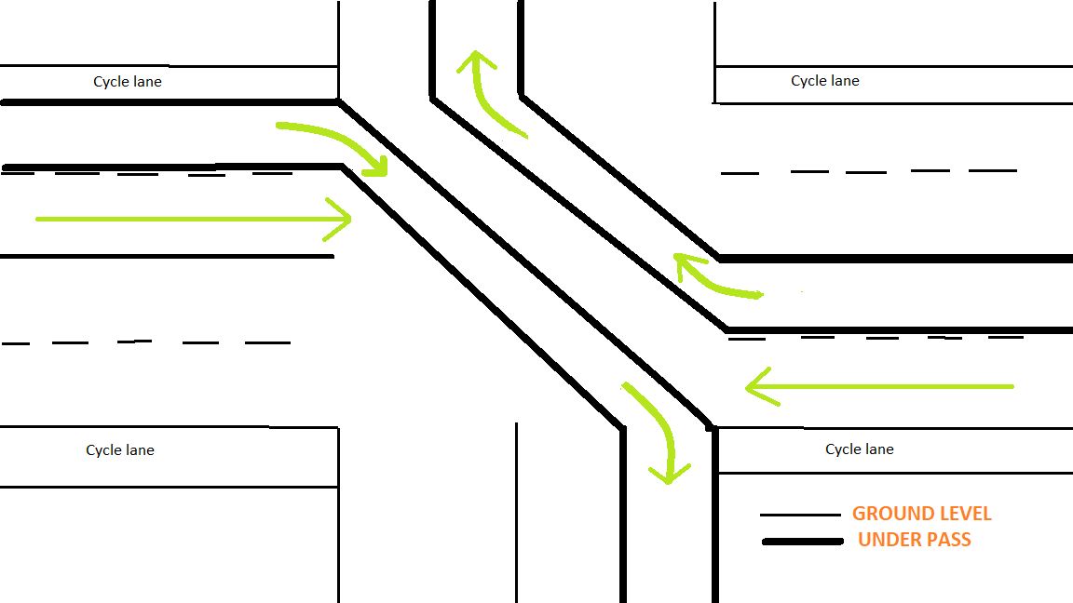

The entrance and exit to the underpass are shown below. The underpass should not be very shallow to avoid construction cost. There should be sign boards to alert the drivers when there is a underpass entrance ahead.

**Summary:**

The above designed model can be used where there is high traffic. Such as main road intersection in the busy area. Since there is lot of empty space below the flyover; those space can be used for commercial parking spots. Bus stops can be located a few 100 meters always from the entrance and exit to flyover and underpass. This will again help in reducing the traffic.

In location which is the outskirts of the city we can have tradition intersection as traffic would be low and won’t result in traffic jams.

Spaces near the entrance and exit of the underpass should have should have safety padding to alert drivers that there is a underpass ahead. This design is best suited if there are six lane roads.

Future improvements:

-Adding design to cross road without having the need to stopping traffic.

-Assuming there might be a lot of space that must be unused at the entrance and exit of the underpass. How can we used the same space and use for the same.